Dear Patient

Many people fear losing their memory and developing Alzheimer’s, believing memory loss is an inevitable consequence of the ageing process and Alzheimer’s is ‘in the genes’. The great news is that Alzheimer’s is not in the genes – less than one in a hundred cases are caused by genes. It is not a natural consequence of the ageing process and a charity, The Food for the Brain Foundation, know how to dementia-proof your diet and lifestyle.

All it takes is 20 minutes of your time. All you have to do to find exactly what, if anything in your diet and lifestyle, is driving your future risk is to take the test at foodforthebrain.org/xxx.

The Cognitive Function Test is both accurate and free. It is followed by the Dementia Risk Index questionnaire, which then works out what’s driving your future risk. Your personal results are worth knowing now, the sooner the better, since prevention start now, not when it’s too late. Here’s an example of what you get, but personalised for you.
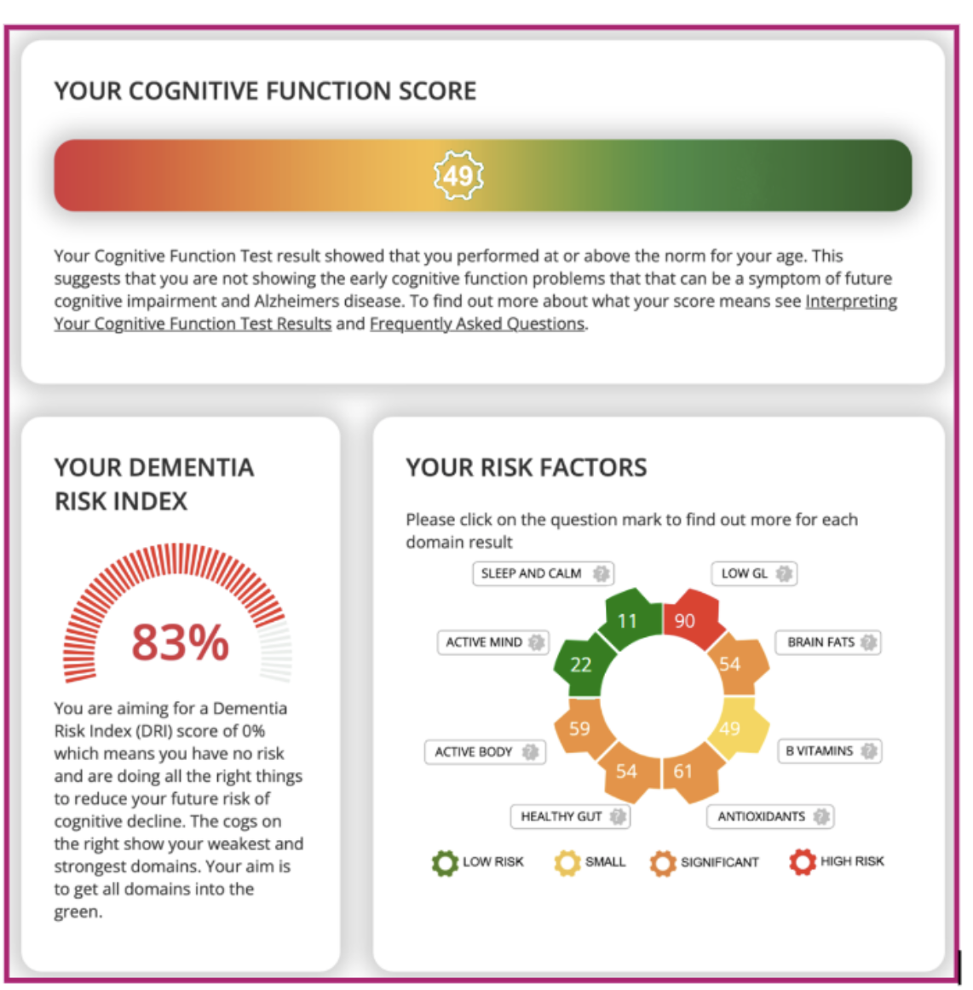
You will be given the option to join a ‘brain upgrade’ support programme called COGNITION designed to dementia-proof your diet and lifestyle. You’ll get emails with things to read, watch and do, ‘push’ text reminders to keep you on track, zoom groups to join, a forum to ask questions and share what works, and will track, month by month, your future risk go down. This is optional and costs either £50 a year or £5 a month for a minimum of six months.

The great news is that all the changes COGNITION motivates and supports you in making are the very changes that reduce your risk of almost every other endemic 21st century mental and physical diseases.

As your doctor/psychiatrist/nutritional therapist I encourage you to take the 20 minutes to take the COGNITIVE FUNCTION TEST at foodforthebrain.org/xxxx and know that, as well as helping yourself, you are, by so doing, becoming a Citizen Scientist because your information helps the Food for the Brain research team to learn what really prevents Alzheimer’s.

xxxxx

