Brain Bio Centre Short Summary Details

This information is to go at the end of the main Brain Bio Centre page, in columns with the other practitioners details. It will link directly to your own practitioner page on the website, which can easily be edited or added to as we get up and running.
You also need to send a head shot for your own page, so you just need to provide the following info:
Word count is limited to 100 words +/- 5
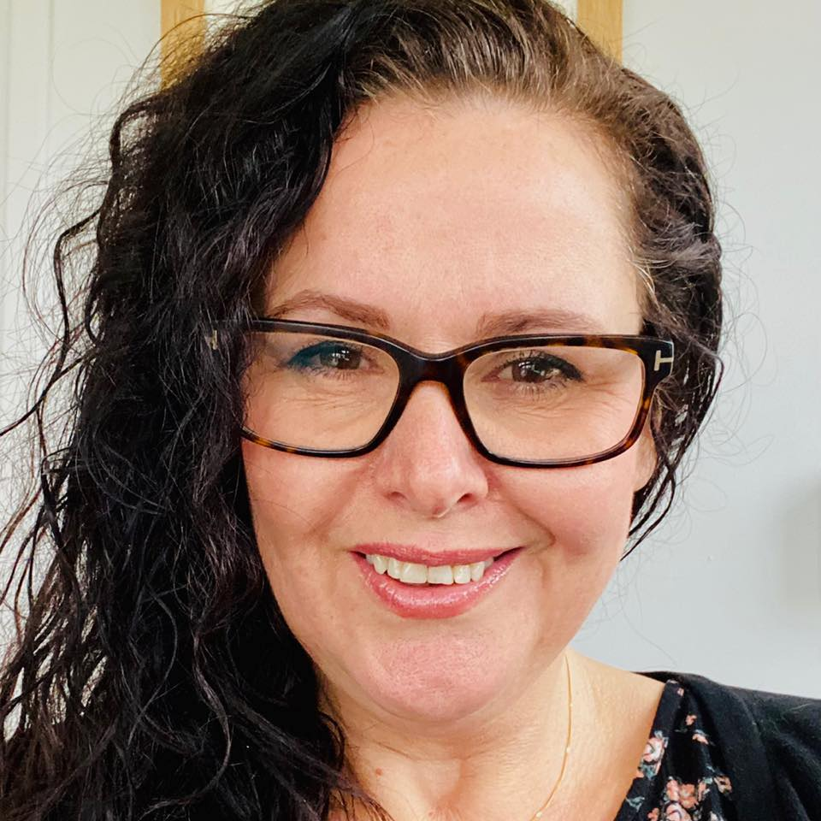

Your name will go here:

Dr Kirstie Lawton, PhD
Qualifications: DipION, BSc Hons Public Health Nutrition, PGCE Higher Education; currently completing an MSc in Neuroscience and Neurodegeneration.

Registration: mBANT, mCNHC, ANutr

Neurodegenerative health conditions: MND/ALS, Parkinson’s Disease, Huntington’s Disease, Multiple Sclerosis

Nutritional psychiatry: Anxiety, depression, OCD, insomnia

Neurodivergence: ADHD, some autism cases

Works with paediatrics and adults.

www.nutritionandthebrain.com
www.younutritionclinic.com

