How to Take Screenshots and Print Your Cognitive Function Test Results
Before You Start
- Log in to your account https://foodforthebrain.org/user_home/
- Open your dashboard
- Make sure your results are visible on the screen
Option 1: Taking Screenshots
For Windows Users
Method 1: Capture the Whole Screen
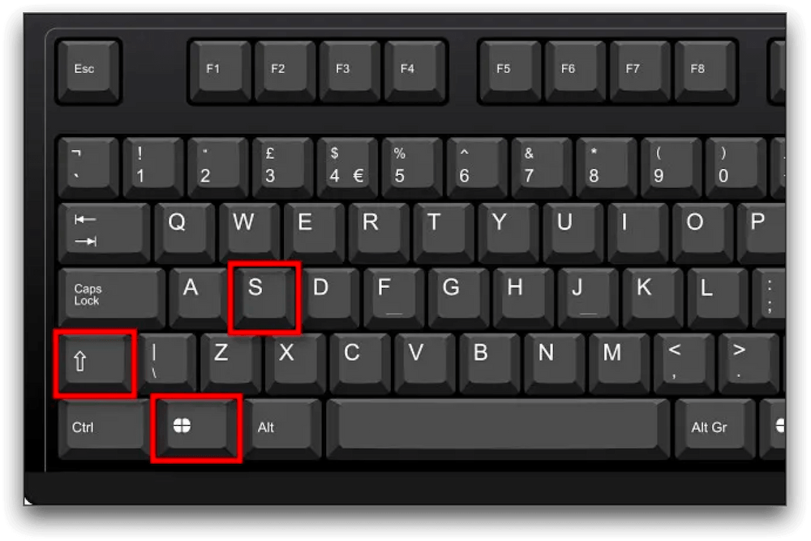
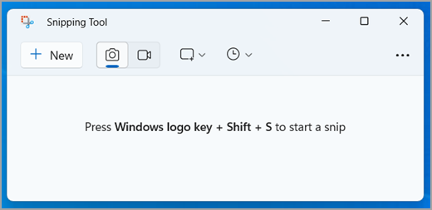
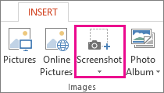
4
- Press the Print Screen (PrtScn) key on your keyboard
- Open Microsoft Word or Paint
- Press Ctrl + V to paste the screenshot
- Save the file

Method 2: Select Part of the Screen (Recommended)
- Press Windows key + Shift + S
- Your screen will dim
- Click and drag to select your results
- The image is copied automatically
- Open Word or Paint
- Press Ctrl + V to paste
- Save the file

For Mac Users
Method 1: Capture the Whole Screen

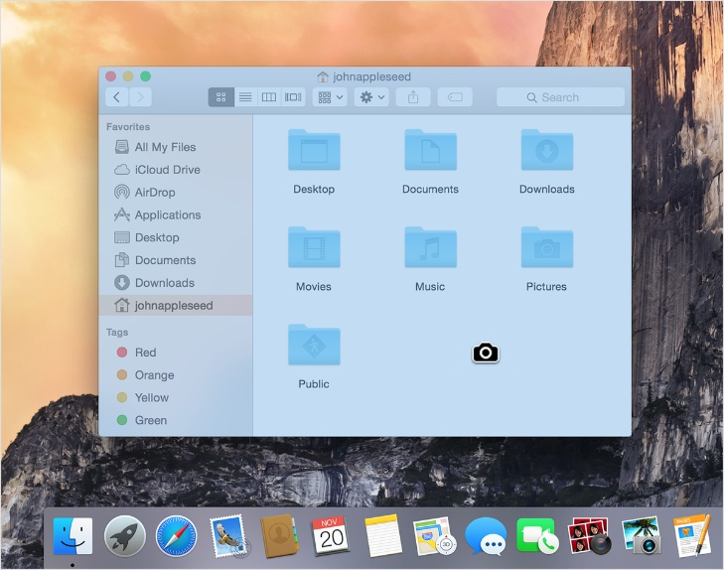
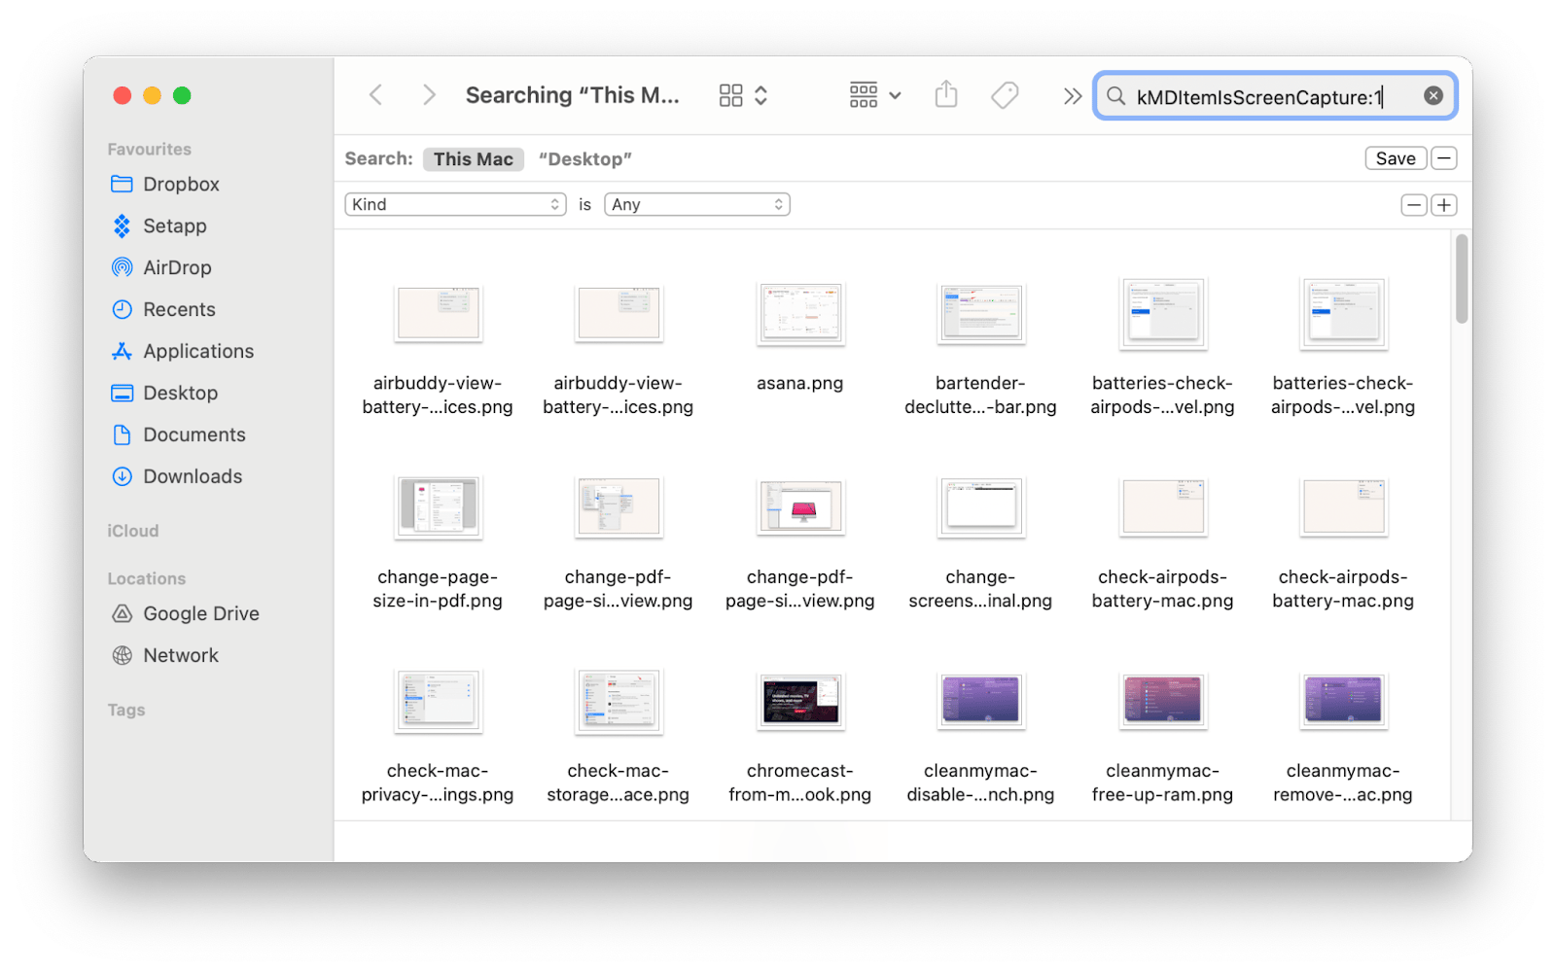
4
- Press Command (⌘) + Shift + 3
- The screenshot is saved automatically to your desktop

Method 2: Select Part of the Screen (Recommended)
- Press Command (⌘) + Shift + 4
- Your cursor will change to a crosshair
- Click and drag to select your results
- The screenshot is saved to your desktop
What to screenshot/Print off
You should screenshot these 3 areas within your results dashboard:
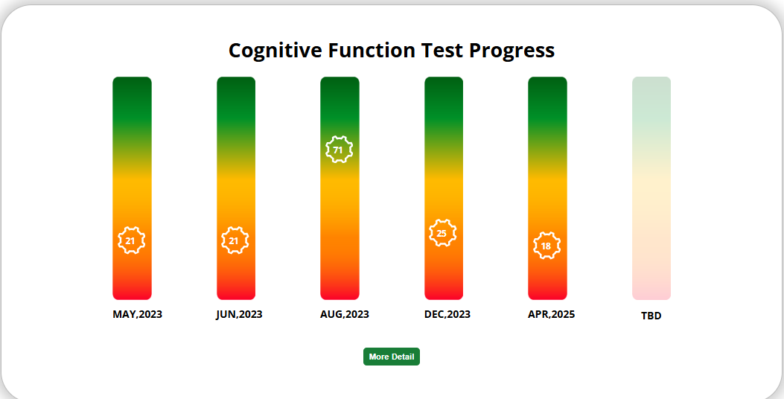
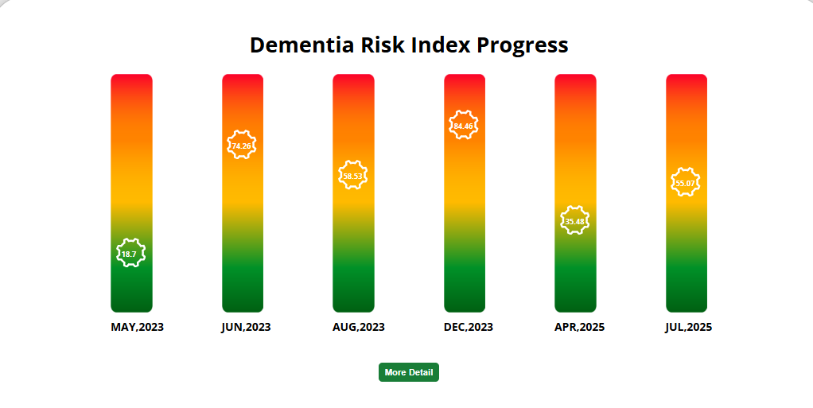
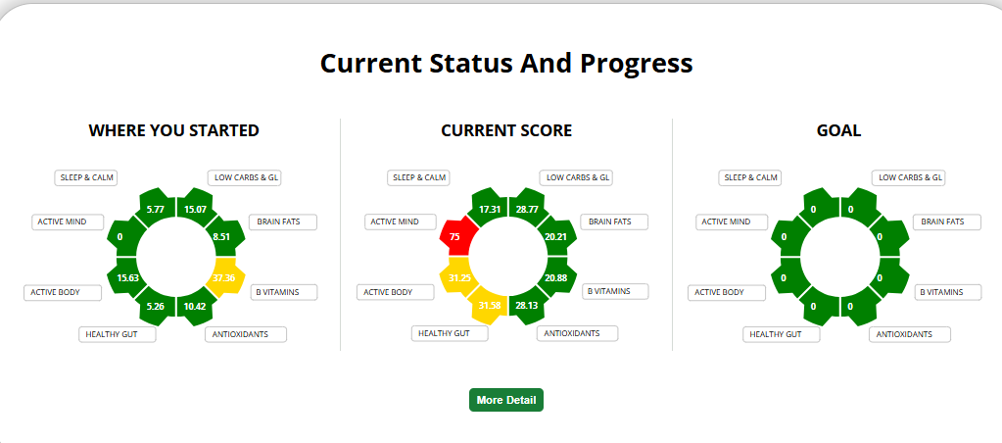

Option 2: Printing Your Results
For Both Windows and Mac
Print from a Screenshot
- Open your saved screenshot
- Press:
  - Windows: Ctrl + P
  - Mac: Command (⌘) + P
- Adjust settings if needed
- Click Print

Tips for Best Results
- Make sure your full results are visible before taking the screenshot
- Scroll and take multiple screenshots if needed
- Use the “select area” option for a cleaner image
- Check print preview before printing

